Patient Therapy Guide

Caution: US Federal law restricts this device for sale by or on the order of a physician

Revi Patient Therapy Guide
All Rights Reserved ©BlueWind Medical Ltd.

Preface
 | This document provides instructions for use and recommended guidelines exclusively for the Revi System supplied and manufactured by BlueWind Medical Ltd.  It is important to read and understand this document before using the Wearable device.

Revi System Label
The Revi Wearable Unit has a label affixed to the back side of the device (visible when the unit is removed from the leg band).
Do not use the device if the label is missing.

Revi Wearable Device
The Revi Wearable Device has a label affixed to the rear of the device (Figure 1). See Table 1 for an explanation of the relevant symbols.

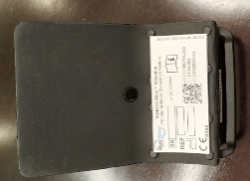
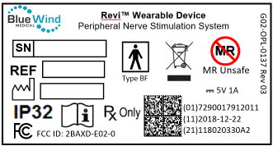
Label
Figure 1: Revi Wearable Device - Label Location

Explanation of Safety Symbols

Table 1 Safety Label - Explanation of Symbols
Symbol Description Symbol Description
 | Serial Number |  | Date of Manufacture (YYYY-MM-DD)
 | Catalog Number |  | Manufacturer
 | Consult Instructions for Use (consult accompanying documents) | 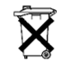 | Dispose of properly after use
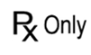 | Prescription device (Caution: U.S. Federal law restricts this device for sale by or on the order of a physician) | 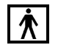 | Type BF Applied Part

Table 1 Safety Label - Explanation of Symbols (Continued)

Symbol Description Symbol Description
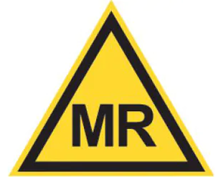 | Magnetic Resonance (MR) Conditional |  | Caution
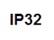 | Ingress Protection | 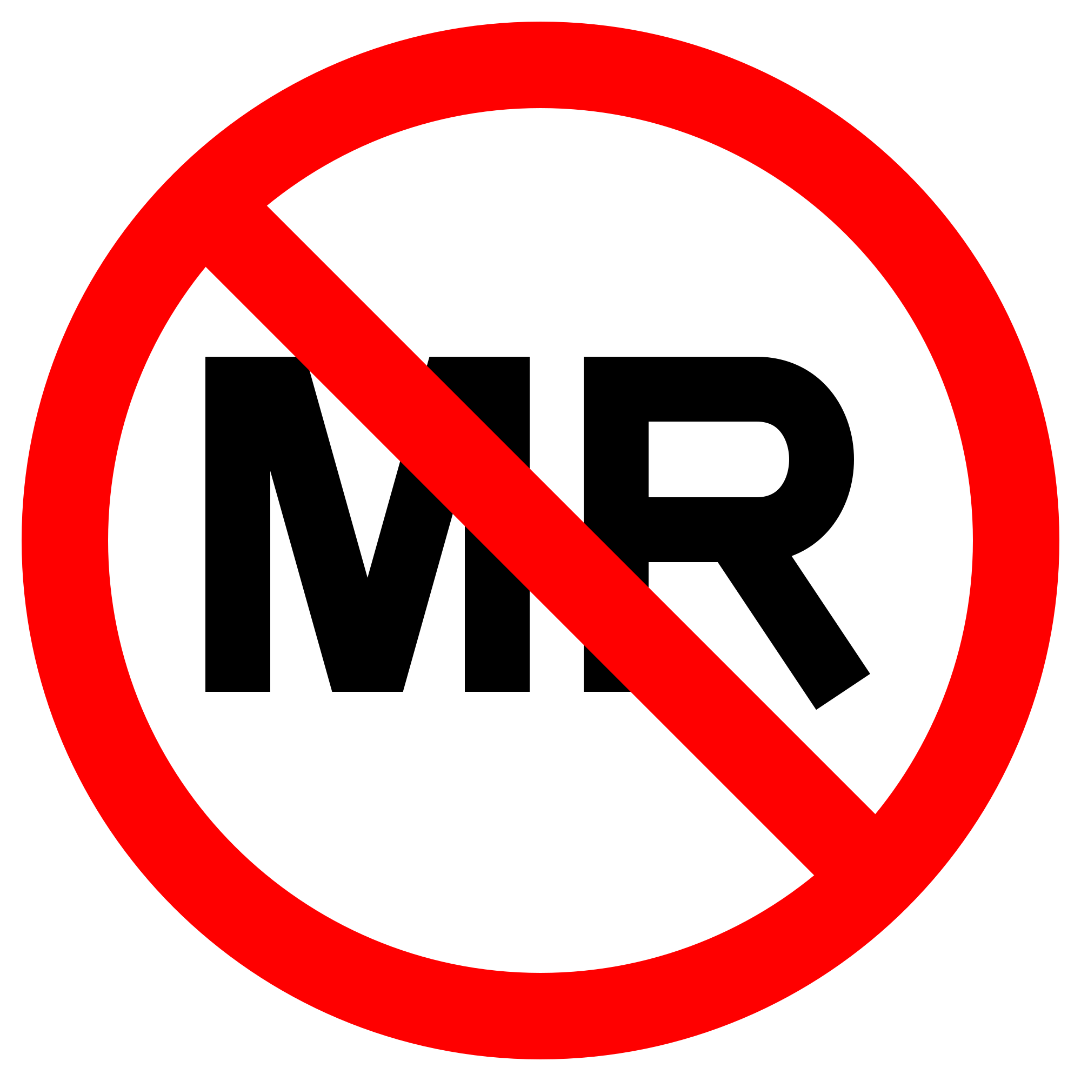 | MR Unsafe
 | Do not use if package is damaged |  | USA Federal Communications Commission compliance

The Revi Patient Kit Contents

The Revi Wearable Unit is supplied in a handy carrying case.
Before use, check that this contains the items listed below:
- Revi Wearable Unit
(comprises a wearable device inside a Leg Band)
- Battery charger and cable
- Revi Patient Therapy Guide (this guide)
- Revi Wearable Unit Quick-Start Guide
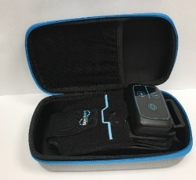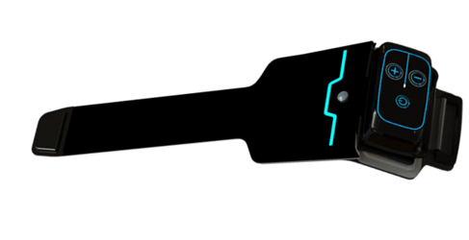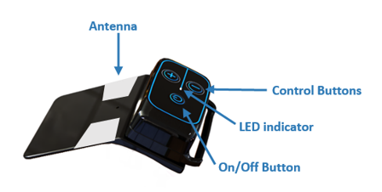
Revi Patient Kit Wearable Unit (with leg band) Wearable Device (without leg band)
Manual Contents

Preface 1
Revi System Label 2
Revi Wearable Device 2
Explanation of Safety Symbols 3
The Revi Patient Kit Contents 5

Glossary 12
Terms and Acronyms 12
Introduction 17
Purpose of the Revi System (Indications for Use) 17
When Should the Revi Wearable Unit Therapy Not be Used (Contraindications)? 17
Use in Specific Populations 19
Warnings 19
Driving/Operating Machinery 20
Flammable Fuel, Chemicals, or Environmental Hazards 20
Medical Therapies/Procedures 20
Diathermy 22
Electromagnetic Interference 22
Magnetic Resonance Imaging (MRI) 23
Implantable Devices 24
Neurostimulator Interaction with Implanted Cardiac Devices 25
Precautions 26
Metal Objects and Implants 26
Strenuous Activities and Excessive Force 27
SCUBA Diving or Hyperbaric Chamber 27
Revi Wearable Unit Placement Site 28
Electromagnetic Interference 28
Strong Electromagnetic Fields 30
Theft Detectors and Security Screeners 31
Travel and International Use 32
Storage and Handling 33
Water Resistance 33
Device Components 34
Service Life 34
Component Disposal 35
What is Revi Therapy? 36
Revi Therapy Session 36
Surgery 37
Stimulation 38
Summary of Clinical Evaluation 39
Potential Adverse Events 41
Revi System 43
Revi Wearable Unit 45
Important to Know 47
Receiving Other Medical Therapy or Treatment 48
Charging the Battery 48
Revi Therapy Session - Before You Start 51
Positioning the Revi Wearable Unit 52
Starting a Therapy Session 55
Ending a Therapy Session 59
Therapy Programs 62
Cleaning Instructions 63
Cleaning the Leg Band 63
Cleaning the Revi Wearable Unit 65

Troubleshooting Guide 66
General Guidelines and Recommendations 66

Tachyphylaxis Instructions 73

System Specifications and Technical Data 74
System Specifications - Technical Information 74
Stimulation Parameters 74
Technical Data 75
Environmental Specifications 79
Electromagnetic Specifications 80
Electromagnetic Compatibility 85
HealthGo Micro Hub 87
Copyright Notice 88
Trademarks 88
Certifications 89

Glossary

Terms and Acronyms

Table 2: Terms and Acronyms Used in this Guide
Term/Acronym | Meaning
BlueWind Medical Representative | The BlueWind Medical Representative is responsible for programming the device as well as training the patient on home use of the device with oversight of the treating clinician/surgeon
Bone Growth Stimulation | Procedures which use either electrical energy or ultrasound to stimulate bone fracture healing.
Diathermy | Diathermy uses high-frequency electromagnetic currents to generate heat in body tissues for therapeutic relief of pain, improving mobility, or increasing blood flow and can use microwave, ultrasound, or short -wave energy.
Electrocautery | Medical procedure which uses electrical current to cut, coagulate, or remove tissues. The electrocautery device generates high-frequency direct electrical currents, typically in the radiofrequency range, which are delivered through a metal tip or electrode. It is different than electrosurgery which uses alternating current. When the electrode comes into contact with the target tissue, the electrical current generates heat, which causes the tissue to be cut, coagulated, or ablated.
Electrosurgery | The surgical use of high-frequency electrical current — applied locally with a metal instrument or needle — used for cutting or destroying tissue.
External defibrillation | An electronic device sending an electric shock to the heart to restore normal heart rhythm.
High-output ultrasound/High-intensity focused ultrasound | Procedures which use high intensity (lower frequency and continuous waves) ultrasound to heat or destroy tissue (such as tumors or non-cancerous enlarged tissues, or to improve blood flow to tissue, or to improve bone fracture healing.
LED | Light-Emitting Diode: an electrical component that emits light.
Leg Band | An adjustable leg band used to place and hold the wearable device over the implantation site for the duration of therapy session.
Lithotripsy | A medical procedure involving the application of ultrasonic waves in order to destruct hardened masses such as stones in the kidney, gastrointestinal system, or gall bladder.
MRI | Magnetic Resonance Imaging. A non-invasive diagnostic procedure for imaging tissues of high fat and water content that cannot be seen with other radiologic techniques.
Neurostimulator | A medical device, producing mild electrical signals for nerve stimulation. The Revi Implant is a Neurostimulator.
Revi Implant | The Revi Implant (or “Implant”) is the implantable wireless neurostimulation component that is placed by your surgeon in the vicinity of your tibial neurovascular bundle. During the therapy session, the implant sends electrical pulses to the tibial nerve using energy received by the Revi Wearable unit.
Revi System | Peripheral nerve stimulation device intended for home-care use.  The system comprises the Revi Implant and the Revi Wearable Unit (with leg band and battery charger).
RF Ablation | Procedures which use radiofrequency energy to ablate (destroy) tumors or other abnormally enlarged tissue, or to cause increased scar formation in joints for weakened ligaments
Tachyphylaxis | Deterioration in response to therapy over time. In neuromodulation, this refers to neural tolerance.
Therapy Session | Therapy delivered by the Revi System for a duration of between half-an-hour and 2 hours, at the discretion of the clinician.
Urinary Urgency | Complaint of sudden, compelling desire to pass urine which is difficult to defer.
UUI | Urgency Urinary Incontinence: Complaint of involuntary loss of urine associated with urgency.¹
Wearable Unit | The external component of the Revi System, comprising a Leg Band holding the Wearable device, that provides power to the Revi Implant and enables control over the therapy session.

Introduction
This user manual contains important information regarding your Revi therapy and is designed to help you use and understand the operation of the Revi Wearable Unit for your optimal management of Therapy Sessions.
Prior to using your Revi Wearable Unit for the first time, make sure you fully understand the training you have been given by the BlueWind Medical Representative and your clinician and the contents of this manual.

Purpose of the Revi System (Indications for Use)
The Revi System is indicated for the treatment of patients with symptoms of urgency incontinence alone or in combination with urinary urgency.

When Should the Revi Wearable Unit Therapy Not be Used (Contraindications)?
The Revi Wearable Unit is contraindicated for the following patients:
- Are unable, or do not have the necessary assistance, to operate the Revi Wearable Unit.
- Men who have obstructive Benign Prostatic Hyperplasia (BPH) or other lower urinary tract obstructions.

Are implanted with any metallic implant within the immediate area (8 in/20 cm distance) of the intended site for the Revi implant implantation.
- Have nerve damage that could impact the therapy session.
- Are at high surgical risk or patients with multiple illnesses or active general infections that expose them to excessive bleeding or delayed or non-healing wounds.
- Have known allergies to one of the implant materials (see implant specifications on page 75).
- Are pregnant
- Have open wounds or sores on the lower leg or foot
- Had prior surgery in the implant area
- Had previous, unhealed trauma in the implant area
- Have pitting edema (≥2+) in the lower leg
- Have Venous disease/insufficiency in the lower leg
- Have Arterial disease/insufficiency in the lower leg
- Have Vasculitis or dermatologic conditions in the lower leg
- Have infections near the implantation site in the lower leg

Use in Specific Populations
The safety and effectiveness of this therapy has not been established for:
- Patients under the age of 18
- Patients with progressive, systemic neurological diseases (e.g., Parkinson’s disease, multiple sclerosis (MS), etc.).

Warnings
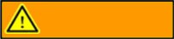
Warnings for use of the Revi Wearable Unit are outlined below, together with recommendations of the manufacturer.
WARNING

Driving/Operating Machinery
Do not operate automobiles, potentially-dangerous machinery or heavy equipment during the Stimulation Therapy Session.
If sudden Stimulation changes occur, they may distract you while operating the vehicle or equipment.

Flammable Fuel, Chemicals, or Environmental Hazards
Do not commence or continue Stimulation Therapy Session while at a petrol-filling station, or in the presence of flammable fuel, fumes or chemicals (including when in an oxygen-rich environment). When the wearable unit is turned ON, or in use, it could potentially ignite the chemicals or fumes, causing severe burns, injury or death. When entering a flammable environment, turn the Revi wearable unit OFF.

Medical Therapies/Procedures
Some medical procedures could damage your Revi Implant and may cause you injury. Talk to your clinician about your Revi Implant before having any of the following medical conditions as these may affect your Revi Implant and should not be used in the implant area:
  - Diathermic therapy (deep heating therapy)
  - Electrosurgery
  - Electrocautery
  - Radiation therapy
  - High-output ultrasound/High-intensity focused ultrasound/Lithotripsy
  - Transcutaneous Electrical Nerve Stimulation (TENS)
  - Bone growth stimulation
  - RF (Radio Frequency) ablation
  - Laser procedures
  - Therapeutic magnets
  - Hyperbaric chamber (oxygen therapy)
Note: The compatibility of the Wearable Unit was not verified with any medical therapy / procedure and thus should be removed prior to any therapy / procedure

Diathermy
Diathermy is a medical and surgical technique that involves the production of heat in a part of the body by high-frequency electric currents. Patients implanted with the Revi implant should not be exposed to shortwave, microwave or ultrasound diathermy, at any location on the body or in their vicinity. Energy from these devices can be transferred through the Implant, causing severe injury or damage to the Implant.
If you should need medical treatment, always confirm with your clinician if this could interfere with your Revi Implant.

Electromagnetic Interference
Energy from common household items and equipment found at home, work, or in public can potentially interfere with the Revi System. This is called electromagnetic interference (EMI).
Although the Revi System is suitable for use in all establishments, including clinics, hospitals and domestic environments, the following warnings apply:
- Do not use the Wearable Unit within 12 inches (30 cm) of:
- Consumer electronic devices, such as TV sets, laptops, tablets and smartphones.
- Metallic objects and strong magnets
- The Revi Wearable Device must emit electro-magnetic energy in order to perform its intended function. Nearby electronic equipment may be affected.

Magnetic Resonance Imaging (MRI)
The Revi Implant is an MR conditional device. Please consult with your clinician so that they may refer to the Revi Surgical Technique Guide for more information.
You should present your Patient Identification Card to MRI staff prior to having an MRI.
The Revi System should not be activated during the MRI procedure.
The Revi Wearable Unit (and accessories) is MR Unsafe and should never enter an MRI room or facility.
The Revi Implant has not been tested simultaneously with other devices in the MRI environment.

Implantable Devices
Do not wear or place the Revi Wearable Unit over implanted devices other than the Revi Implant. Other implanted devices such as pacemakers, cardioverter defibrillators, implanted drug pumps, etc., could be adversely affected and impacted by the wearable device.
The effect of the Revi System on the operation of other implanted devices, such as other neurostimulators, and implantable drug pumps, is not known. In particular, if the Revi System is implanted close to one of these devices, they may have sensing problems and/or may not function correctly. Potential interference issues should be investigated before surgery by clinicians involved with both devices. The programming of the devices may need to be optimized to provide maximum benefit from both devices.

Consult your clinician if you need to be implanted with this kind of system.

Neurostimulator Interaction with Implanted Cardiac Devices
When you are in need of both a Revi System and an implanted cardiac device (for example, a pacemaker, defibrillator/cardioversion), interactions between the two devices should be discussed by the patients’ physicians involved with both devices (such as the cardiologist, electrophysiologist, urologist, and urogynecologist) before surgery as these devices can damage your Revi Implant. The stimulation pulses produced by the Revi System may interact with cardiac devices that sense cardiac activity, leading to inappropriate behavior of the cardiac device and the Revi Implant.
If you do receive implantation of external defibrillation, your clinician should confirm that the Revi system is working as intended.

Precautions
Treating Clinicians/Surgeons should follow current clinical guidelines as applicable and should use their discretion to determine whether the patient should fail or not tolerate more conservative treatments before using the Revi System.

Precautions for use of the Revi System are outlined below, together with recommendations of the manufacturer.

Metal Objects and Implants
External and implanted metal objects can impact the communication between the Revi Wearable Unit and Implant when placed near the system. This may prevent or reduce the system's therapy session.
As a precaution, follow these guidelines:
  - If you need a metal implant inserted in the vicinity of the Revi Implant, consult with your clinician regarding the impact.
  - Keep metal items at least 8 in (20 cm) away from the Revi Wearable Unit while performing the Stimulation therapy session.

Strenuous Activities and Excessive Force
You should avoid strenuous activities (and excessive force) that put the Revi Implant under extreme stress. If the Implant casing is ruptured or pierced due to outside forces, the Implant will no longer be functional, and injury may result.
The following examples of strenuous activities can damage the Revi Implant resulting in loss of symptom relief and possible additional surgery: Gymnastics, Mountain biking, Skiing, Sky diving.
Less extreme activities should not impact your Revi Implant: Running, Jogging, Road biking, Swimming.

SCUBA Diving or Hyperbaric Chamber
SCUBA diving or going inside a hyperbaric chamber may damage the implant.

Revi Wearable Unit Placement Site
The Revi Wearable Unit is Non-Sterile and not to be sterilized and should not be applied to an open wound. Contact with an open wound could cause an infection.
Do not use the Revi Wearable Unit if the skin in the area surrounding the implant site is inflamed, infected, or otherwise compromised.
Swelling along with pain, warmth and excessive redness in the implantation site could be a sign of infection, Implant rejection or an allergic reaction to the Leg Band material.
If you experience these symptoms near the Wearable Unit's placement site, contact your clinician before using the device.

Electromagnetic Interference
The Revi System has features to protect from electromagnetic interference (EMI) and most common household items and equipment you encounter on a daily basis are unlikely to affect your Revi therapy. However, EMI and/or radiofrequency from electrical devices may disrupt the communication between the Revi Wearable Unit and the Implant in certain situations, causing the Stimulation to either stop or be uncomfortable.
Keep your distance from powerful electrical items to reduce the risk of potential problems. As a precaution, follow these guidelines:
    - If you suspect that an EMI equipment or environment is affecting the function of your Revi System, avoid performing the therapy session around that item by doing the following:
      - Move away from the electrical item
      - Turn off the electrical item (if possible)
    - If you are unable to eliminate the interference or believe the interference has altered the effectiveness of your therapy, you should contact your clinician.
Sources of strong EMI can result in the following:
- Patient injury, resulting from heating of the Revi System that causes damage to surrounding tissue.
- System damage, which may require surgical replacement due to change in symptom control.
- Operational changes to the Revi Wearable Unit, causing it to turn on or off or to reset the settings, resulting in loss of stimulation or return of symptoms, causing a need for reprogramming.
- Unexpected changes in stimulation, leading to a sudden increase or change in stimulation, which may be experienced as a jolting or shocking sensation. While the sensation may be uncomfortable, the device would not be damaged, nor would it cause direct injury. In rare cases, the change in stimulation may cause you to fall and be injured.

Strong Electromagnetic Fields
Strong electromagnetic fields can impact the communication between the Revi Wearable Unit and the Implant in certain situations, causing the Stimulation to either stop or be uncomfortable.
As a precaution, avoid performing Therapy Sessions around:
    - Power lines or power generators.
    - Electric steel furnaces.
    - Large stereo speakers.
    - Short-wave or microwave therapy equipment.
Note: For more details, refer to Electromagnetic Specifications on page 80.

Theft Detectors and Security Screeners
Everyday electrical devices are not likely to affect Revi. There are strong sources of EMI that have a higher risk. These include theft detectors or security screeners such as those used at department stores, and/or airports.
It is possible that such devices may affect the communication between the Revi Wearable Unit and the Implant, causing the Stimulation to either stop or be uncomfortable. Security screeners may also detect the metal in your Implant. Airport authorities advise patients to carry their Patient Identification Card with them when traveling.
As a precaution, if you encounter security or theft detectors, walk far away from the sides of them when passing through and avoid performing your Revi therapy sessions around them. Make sure security staff are informed that you have an implanted stimulator and carry your patient identification card with you for verification.

Travel and International Use
When traveling, it is important to continue adhering to your Revi Therapy regimen. You should carry your Patient Identification Card when traveling.
It is possible that airport security devices may affect the communication between your Revi Wearable Unit and your Revi Implant.
For more details, refer to the precautions provided in Theft Detectors and Security Screeners on page 31.
During flight, the communication between the Revi Wearable Unit and the Revi Implant may cause interference with the navigation or communication system of the aircraft.
As a precaution, do not perform a Therapy Session during flight.

Note: You may need a power adapter when using the battery charger in different countries.

Storage and Handling
Handle the Revi Wearable Unit with care. Dropping the device on hard surfaces, or other rough handling, can damage it. Please contact your clinician if you think your unit is not functioning properly to get it evaluated.
Store your Revi Wearable Unit in a secure location easily accessible by you only.
It is recommended to store your Revi Wearable Unit in a dry and room-temperature environment.
Avoid exposing the device to extreme temperatures or moisture (during operation ambient temperature should be 60 - 90°F; during transport/storage, 14 - 131°F. Relative humidity should not exceed 85%). For example, do not leave the Revi Wearable Unit in your car or outdoors for extended periods of time.
Note: See Table 7 on page 79 for recommended storage temperatures.

Water Resistance
The Revi Wearable Unit is water resistant, but not waterproof (i.e., water can be repelled to some degree but not completely). Do not use the device in or around water.
Using the wearable device while / after it has been immersed in water could lead to electrocution or damage to the device.
If the device has been damaged, contact your clinician for replacement.

Device Components
Please do not tamper or modify the Revi Wearable Unit. No modification of this equipment is allowed.
Your Revi Wearable Unit is intended to be used only by you. Use of components from other systems or modified components may damage the system or cause injury.

Service Life
The Revi Wearable Unit service life is 1 year.
The Revi Implant lifetime is 10 years from implantation.
Nevertheless, stimulators can fail due to random component failure, or loss of battery functionality.
In any case where one of the system components is damaged or stops working, the component should not be used.
If the Revi Wearable Unit has been damaged or stops working, contact your clinician for evaluation and/or replacement.
If the Revi Implant reaches its end of life (10 years from the implantation date on your patient ID card), contact your clinician.

Component Disposal
The Revi System must not be disposed of in municipal waste.
Contact your clinician or BlueWind Medical Ltd. (see back cover of this guide for contact details) for instructions on returning the unit to the manufacturer.
Disposal of the battery charger should be in accordance with local municipal guidelines.

What is Revi Therapy?
Before deciding whether or not Revi therapy is appropriate for you, it is important to discuss and assess the benefits and risks with your clinician, in order to make an informed choice. The following information explains the benefits and risks and describes what to expect from the Revi System Therapy.

Revi Therapy Session
The Revi System is intended to provide neuromodulation therapy that can relieve symptoms of urge urinary incontinence (UUI) and urinary urgency. The Revi system uses mild electrical pulses to stimulate the tibial nerve located in the lower leg.
Revi therapy does not provide a cure for your UUI and urinary urgency related symptoms. However, the therapy session is likely to reduce your symptoms to a tolerable, or even normal, level and allow you to resume many of your normal daily activities.

Surgery
The first step toward receiving the therapy session is a surgical procedure to place the miniature stimulator (Revi Implant) in your leg, near the tibial nerve. As with any surgical implantation, there are risks related to the surgery itself and almost all of them are expected to resolve on their own, or with medication, within a period of days to weeks. Since the Revi Implant is very small and implanted peripherally (in the lower leg), the risks are relatively low (see Possible Adverse Events on page 41).
For a small number of patients, the therapy session will not improve the symptoms (or more rarely, the device may fail). If you are among them, and you and your clinician decide to remove the implant, or in the event of a complication requiring implant removal, additional surgery will be required.
The advantage of having a neurostimulator implanted is that you can perform daily therapy session at home, tailored to your individual needs.

Stimulation
For each Therapy Session (typically, 30-60 minutes), the Revi Wearable Unit is placed around the leg, strapped into position over the Implant site, then activated.
The unit transmits energy to the Implant, which sends electrical pulses to the tibial nerve. This will feel like a tingling sensation in the heel, sole and/or toes. These electrical pulses stimulate the nerve along your leg and reach the nerves in your pelvis that control the bladder, urinary sphincter and the pelvic floor. This Stimulation has the power to modulate (adjust) the function of nerves (therefore called Neuromodulation), calming the bladder and relieving your symptoms.
Neuromodulation therapy has been an alternative for patients with urinary control problems who did not respond to or could not tolerate other treatments - such as, a change in diet, medication, biofeedback, or catheterization.
There are additional risks related to the Stimulation itself (see Possible Adverse Events on page 41). The majority of events are resolved either on their own or by adjusting the Stimulation settings. Remember, you are in control of your own therapy session, you can adjust the Stimulation at any time within a predetermined range of stimulation levels.

Summary of Clinical Evaluation
BlueWind Medical studied Revi in people with frequent and sudden urges to urinate and in people who had bladder leaks due to urgency.

The first clinical study, OPTIMIST, was a pilot study which provided limited data, and included 36 people (31 women and 5 men) to see how well Revi improved their symptoms. At 6 months follow-up, male subjects implanted with the Revi System demonstrated similar safety and effectiveness outcomes compared to the female subjects. Additionally, the pilot study data provided preliminary support of the durability of the Revi System treatment through 3 years of follow-up. The 3-year pilot study data demonstrated no reduction in device effectiveness over time (tachyphylaxis),

The second study, OASIS, looked at how well Revi improved problems of sudden bladder leaks (urgency incontinence) in a larger group. In OASIS, 151 women were implanted with Revi and their progress was checked at 1 year, and if they wanted, they could continue for 3 years. After 1 year, 78% had fewer than half the sudden bladder leaks as they had before. Most women in the study also reported fewer large leaks, fewer strong urges to urinate, and also reported their lives improved. Some women (10.6%) in the study had mild to moderate issues, including numbness after surgery, pain, swelling, skin rash, wound infections, and delayed healing. There were no serious complications at 1 year.

Potential Adverse Events
Potential risks are associated with any implantation surgery or use of a neurostimulation system.
Risks associated with the Revi Implant Procedure:
Anticipated adverse events involved with the surgery include but are not limited to the following: bleeding (bruising), pain at the implantation (stimulator) site, ankle discomfort, implant site infection, skin irritation, skin erosion, edema, wound dehiscence, seroma, formation of thrombosis and pulmonary embolism, potential temporary or permanent mobility impairment and nerve injury.
Risks associated with the use of the Revi Wearable Unit:
Anticipated adverse events involved with the stimulation include: undesirable changes in stimulation such as sensation of transient electric "shock"/sudden radiating sensation, sporadic sensory response, uncomfortable heating effects, discomfort, burn, or transient muscular spasm induced by stimulation.
Anticipated adverse events involved with the therapy session include: adverse changes in voiding/bowel function, transient nausea.
Anticipated adverse events involved with the device include: spontaneous sensory response (not in association with stimulation), implant migration or displacement, allergic reaction and technical device problems.
Adverse events that were reported in a previous study, included 4% device related Adverse Events, all of which were reported as pain associated with the device (i.e., treatment/stimulation), and 10.6% procedure related AEs, of which 6.6% were related to the surgical wound.
Most adverse events resolve within a few days to a few weeks on their own or with medication.

Revi System
Revi System is a peripheral nerve stimulation system intended for home-care use. The system comprises the following components (illustrated in Figure 2):
- Revi Implant - a small neurostimulator device that generates mild electrical stimulation, similar to a pacemaker. The implant was placed within your lower leg by your surgeon, using a minimally-invasive surgical technique.
- Revi Wearable Unit - an external wearable device used to control therapy. This device acts like a wireless ‘power supply’ to your Revi Implant, enabling you to control and manage your therapy session by starting and stopping your therapy sessions, adjusting the strength of the Stimulation pulses, and maintaining a comfortable level of Stimulation.
- HealthGo Micro (Hub) – a hub for use at home, which transfers data from the Wearable Unit to the cloud for the purpose of remote support.

Note: An additional component (a hand-held tablet device) will be used during your clinic visits, to communicate with your Revi Wearable Unit via a wireless (Bluetooth) connection.
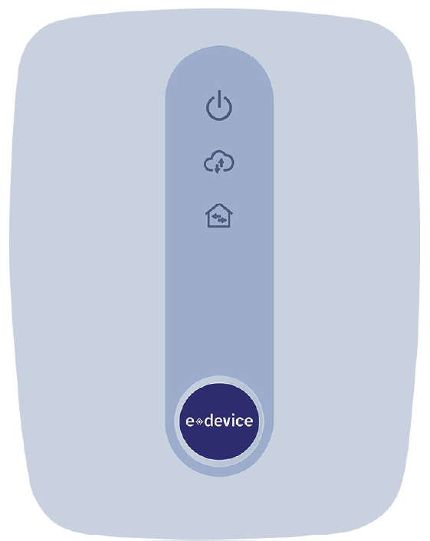
3
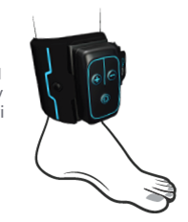

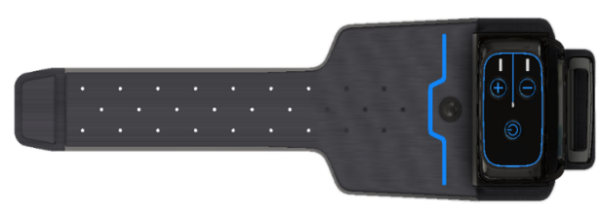
2

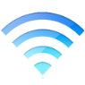
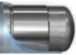
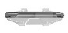
Electrode
1

1 | Revi Implant
2 | Revi Wearable Unit
3 | HealthGo Micro Hub

Revi Wearable Unit with Leg Band strapped in position for a Therapy Session
Figure 2 Revi System Components and Communication

Revi Wearable Unit
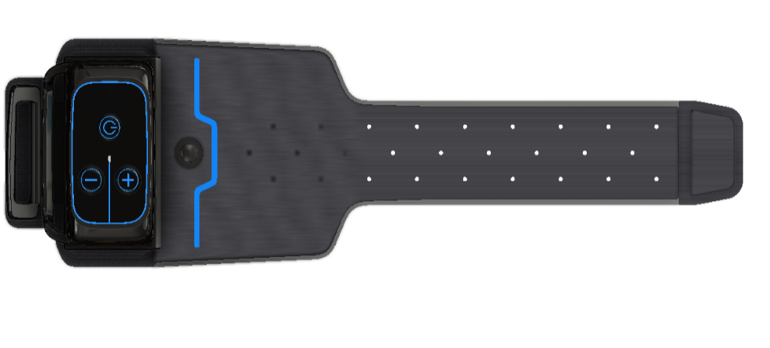
You will be provided with the Revi Wearable Unit which is supplied within its own carrying case, together with a Leg Band and a battery charger. Also included is this Patient Therapy Guide and a Quick-Start Guide. Figure 3 shows the unit in the Leg Band ready for use and illustrates the controls and indicators.
6
5
7
2
1
8
4
3
1 | Power Button
2 | Led Indicator
3 | "+" Button
4 | "-" Button
5 | Antenna Positioning/Treatment Indicators
6 | Antenna center marking
7 | Fabric strap
8 | Charging Connector

Figure 3 Revi Wearable Unit - Controls and Indicators
Your Revi Wearable Unit will be programmed so that it provides the therapy that is most suitable for you.
After programming your therapy session parameters, you will be trained to use your unit to perform your own Revi therapy sessions. You will be told about the precautions and warnings to be aware of. If you have any questions or problems with your wearable unit, ask your clinician for more training or information.
If you have not received training, contact your clinician before using your Revi Wearable Unit for the first time.
For easy reference, see these guidelines and recommendations for optimal use of the Revi system:
  - Important to Know - Page 47
  - Receiving Other Medical Treatment - Page 48
  - Charging the Battery - Page 48
  - Revi Therapy Session - Page 51
  - Cleaning Instructions - Page 63

Important to Know
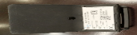 | In addition to observing the safety information provided in Warnings on page 19 and Precautions on page 26, it is important to know the following:

  - Keeping a voiding diary will help you track improvements in your symptoms over time.
  - Adhering to the therapy session regimen prescribed by your clinician is very important. It will help you achieve the best results.
  - A patient identification card was given to you by your clinician that contains basic information about you and your Revi System.
You should carry the patient identification card with you at all times since this identifies you as a person with a Revi Implant and undergoing therapy session with the Revi system. If you lose your patient Identification card, please contact your clinician for a new card.

Receiving Other Medical Therapy or Treatment
In the event that you require any other type of medical examination, therapy, treatment, surgical operation, etc. it is important to notify your clinician or relevant medical professional that you are using the Revi system.

Make sure your attending medical professionals know that you are implanted with the Revi Implant and are aware of the associated warnings. See Medical Therapies/Procedures on page 20.

Charging the Battery
Your Revi Wearable Unit is powered by a rechargeable battery, sealed inside the Wearable unit.
The length of the battery power will depend on your Stimulation settings. Like any battery-powered device, the more it is used and the higher the settings, the faster the battery power becomes depleted. While recharging the battery could be required only once per week, or as often as once per day, it is recommended to charge the Wearable unit after each therapy session, so it is ready for your next therapy session.
When the Revi Wearable Unit is connected to the battery charger, the LED light color and state (blinking or steady) indicates the current battery power status. See the illustration in Figure 4.
The battery inside the Revi Wearable Unit could become excessively hot during the battery-charging process.
As a safety precaution, the Revi Wearable Unit is programmed to prevent you from starting Therapy Session, while the unit is connected to the battery charger. As an additional precaution, follow these guidelines:
- Do not charge the battery while the Wearable Unit is on the leg.
- Use only the charger provided to you with the Revi system.
- During the battery-charging process, the charger may become warm - handle with care.
Use only the AC adapter and USB cable designed exclusively for your Revi System to connect to the USB port.

To Charge the Battery
- Make sure the Revi Wearable Unit is turned Off. (If it is On, press and hold the power button to turn Off).
- Connect the battery charger cable to the Revi Wearable Unit power input socket (see Figure 3, 8).
- Plug the battery charger into a wall outlet.
Battery charging starts.
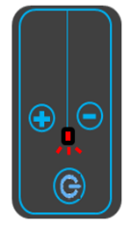

Battery Charging in Progress
The LED light blinks while charging, changing color from red to green according to charging status.
When fully-charged, blinking
stops and the LED light is steady green.
LED Blinking Red
LED Blinking Green
LED Steady Green
Battery Power INSUFFICIENT
for Therapy Session
Battery Power SUFFICIENT
for Therapy Session
Battery Fully-Charged
Figure 4 Charging the Battery

Revi Therapy Session - Before You Start
- Make sure the Revi Wearable Unit is secured inside the Leg Band.

- Press the Power button to turn the unit On.
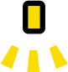
The unit is ready for positioning when the LED blinks orange
Proceed to Positioning the Revi Wearable Unit.
Note: It will not be possible to initiate a Therapy Session if the battery is not sufficiently charged to complete an entire session.
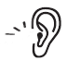
If the battery does not have enough charge, when you turn the unit on, you will hear a sound, the LED will light up red, and then the unit will turn off.
Recharge the battery - see Charging the Battery on page 48.
Note: If the wearable unit does not turn on, connect it to the wall outlet using the charger. You will either:
See the LED blinking red - the wearable needs to be charged, OR:
See the LED blinking green and hear three beeps - you may continue by disconnecting from charger and pressing the Power button again.
Note: While the unit is connected to the charger, the unit will not respond to Power button press.

Positioning the Revi Wearable Unit
The strength of the signal between the Revi Wearable Unit and the Revi Implant is indicated via blinking of the LED (Figure 5, 1) and audible sounds. This corresponds to the accuracy of the unit’s position.
As the unit locates the Implant, you will hear a beeping sound.

The LED blinks orange.

Indicators for Correct Positioning:
Indicators for better positioning are:
- Faster beeping sound
- Faster LED blinking

The indicators mark good positioning over a range of locations. The best positioning is achieved in the highest point of this range.

Positioning the Revi Wearable Unit for Therapy
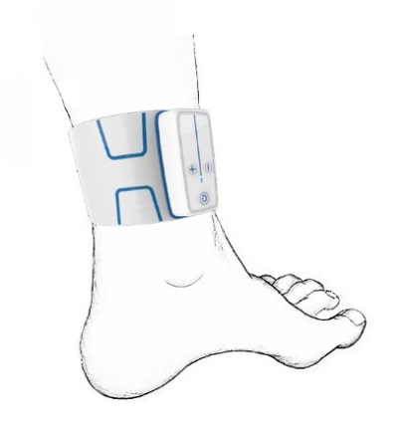
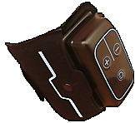
  - The Wearable unit box (Figure 5, 4) should be at the front of the leg and the rest of the Wearable Unit should be on inner part of the leg.
3
2
1
4
  - Pass the strap through the loop without tightening.
  - Align the antenna marking (Figure 5, 3) of the Wearable with the scar.
Figure 5 Positioned for Therapy
Position of Wearable Unit shown on the LEFT leg. For the RIGHT leg, Power button (1) will be at the top.
  - Adjust the height according to the beeping and flashing frequency – Place the Wearable as high as possible on the leg while maintaining the fastest possible beeping and flashing frequency. To do this, raise the Wearable slowly until you hear the signal slowing down, then bring it back down slightly to the last point (-highest point) with fast signals.
  - Tighten the strap to a secure, yet comfortable, level.

You are now ready to start a Revi Therapy Session.
Note: If you do not start the Therapy Session within 5 minutes of positioning, the Revi Wearable Unit will turn Off automatically.

Starting a Therapy Session

To Start a Therapy Session
- Make sure the Revi Wearable Unit is correctly positioned, as described previously.
- Press the Power button once - just a short press - to start Therapy Session.
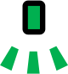
You will hear a sound; the LED will blink green.
The unit will slowly ramp up the Stimulation level that you set during the previous Session (or for the first Therapy Session, to the customized level set by the BlueWind Medical Representative and your clinician).
Note: During this stage, you may start sensing the Stimulation in your leg, as a tingling sensation in the bottom of your foot and/or toes. This is normal.

Once the unit reaches the Stimulation level, the blinking stops and the LED
shows a steady green light.
This indicates the desired level has now been reached.
- If necessary, you may adjust the Stimulations to make them stronger or weaker (using the + or - buttons as shown below), until a strong, yet comfortable, level is reached.

INCREASING the Stimulation Level

To INCREASE Stimulation by one level: Press this button once.

You will hear a beep; the green LED will blink for a few seconds (to indicate ramp-up of the Stimulation level), then will show a steady green light.
Steady green indicates the increased level has been reached.

To further INCREASE Stimulation:

Wait until ramp-up is complete, then press this button again for as many times as necessary until you reach the required stronger Stimulation level.
At each button press, you will hear a sound; the green LED will blink for a few seconds (to indicate ramp-up of the Stimulation level), then will show
steady green. This indicates the level has been increased.

DECREASING the Stimulation Level

To DECREASE Stimulation by one level:
Press this button once.
You will hear a beep; LED will blink once, and then will remain steady green.
To further DECREASE Stimulation:
Press this button again for as many times as necessary until you reach the intended weaker Stimulation level.
At each button press, you will hear a beep; the LED will remain steady green.
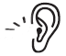
Note: If you are trying to INCREASE or DECREASE the Stimulation level when the maximal (or minimal) level has already been reached: The unit will indicate that this is not possible by sounding three consecutive beeps.

If pain or discomfort occurs during or as a result of your Therapy Session, decrease the Stimulation level by pressing the button. You can also simply turn off the Wearable by pressing and holding the button or simply remove it from your leg.
If pain/discomfort persists, contact your Clinician.

What Should I do if Stimulation Turns On and Off at Regular Intervals?
Your Revi Therapy Session may have been programmed so that Stimulation is turned On and Off at regular intervals.
During the Off phase, the green LED will blink slowly.
If you are not sensing Stimulation and are not sure if the Therapy Session is ongoing, check if the LED is blinking. If the LED is Off, then the Therapy Session has ended.

What Should I do if the Unit Loses Communication with the Implant?
In some cases, the Revi Wearable Unit may move out of position and lose communication with the Implant. For example, when the unit is not securely fastened around your leg or when it is accidentally bumped into another object.
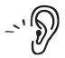 If this occurs during a Therapy Session, the unit will sound an alert and the LED will blink orange.

Proceed as follows:
- Loosen the strap on the Leg Band.
- Move the Revi Wearable Unit over the Implant area until optimal positioning is reached, indicated by rapid blinking and beeping.
- Refasten the strap, then press the Power button once – just a short press - to restart your Therapy Session.
Note: The Therapy Session will automatically restart from the point at which it previously stopped.

Ending a Therapy Session
The Revi system continues Therapy for the duration set. Once the Session ends, the unit will turn Off automatically.
The LED light will be a steady red for a few seconds.
A sound will indicate the Therapy Session has ended.
When the session has ended, unfasten the Leg Band and remove from your leg. Store the Revi Wearable Unit in the carrying case.

Can I End a Session Before Therapy is Completed?
Yes. Your clinician defines the duration of the Therapy Session — however, if you find it necessary, you can end the session before Therapy completion:
Press and hold the Power button until the Revi Wearable Unit indicates it is shutting down.
The LED light will be a steady red for a few seconds.
A sound will indicate the Therapy Session has ended.

Can I Simply Remove the Unit to Stop a Therapy Session?
Yes. You can unfasten the Leg Band and remove the Revi Wearable Unit from your leg, without pressing the Power button.
As you move the unit away from your leg, the Implant will no longer receive energy from the Wearable Unit and you will no longer receive Stimulation pulses.

Therapy Programs
Your clinician will provide you with up to four Therapy programs. If your Wearable Unit was set up with more than one Therapy program, a BlueWind Medical Representative will guide you through the process of changing it if and when a program change is required.
Do not attempt to change the therapy program on your own.

For the purpose of therapy program change, use only the charger provided to you with the Revi System.

Cleaning Instructions
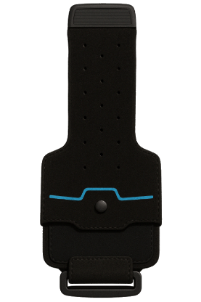
The Revi Wearable Unit is provided Non-Sterile and not to be sterilized.
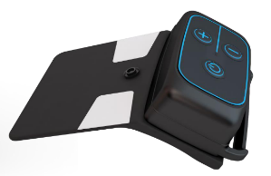

Figure 6 Leg Band
Figure 7 Wearable Device

Cleaning the Leg Band
Hand wash the leg band (Figure 7)approximately every 4 weeks according to the following instructions:
- Remove the Revi Wearable Device from the Leg Band.
- Fill a sink or a bowl with lukewarm water at a temperature of 95°F ± 41°F (35°C ± 5°C).
- Add 2 teaspoons of mild liquid hand-washing detergent.
- Submerge the Leg Band in the soapy water and soak for 15 minutes. With the hands, work the suds into the leg band.
- Use gentle movements to swish the Leg Band through the sudsy water. Avoid scrubbing or twisting which can stretch or damage the fabric.
- Remove the Leg Band from the water.
- Hold the leg band under a faucet and let lukewarm water run over it, rinsing out any soapy water. Be sure to rinse until the leg band no longer releases any suds.
- Lay the leg band flat on a towel and lay another towel over top and press to remove water.
- Hang the leg band to dry at room temperature – do not tumble-dry or use heat.

Cleaning the Revi Wearable Unit
If cleaning of the Revi Wearable Unit is required (Figure 7), follow the recommendations of the manufacturer outlined below.
Do not immerse the unit in water or allow liquids to seep into the components.
Do not use abrasive scouring powders or pads, caustic detergents, ammonia, or
acid-based cleaning solutions.
Use of these materials may cause irreparable damage to system components!

- Ensure the unit is turned Off and the battery charger is disconnected.
- Clean the unit’s surfaces using a damp wipe, moistened with water or alcohol.
- Dry with a soft, clean cloth.

Troubleshooting Guide

General Guidelines and Recommendations
Table 3 provides a troubleshooting guide to assist you with difficulties when using the Revi Wearable Unit.
Note: If any problem remains unresolved, contact your clinician or BlueWind Patient Support so that your Revi system can be evaluated.
Who to contact for help?
Please contact your clinician if you have questions about your health or the Revi Wearable Unit.
Revi Wearable Unit Support:
For questions regarding the Revi Wearable Unit, additional information, and product manuals, visit our website or contact your clinician or BlueWind Patient Support.

Table 3 Troubleshooting Guide
Situation Possible Cause Recommended Action
The Revi Wearable Unit does not turn On. | Insufficient battery power. | Check the battery status by  connecting it to the battery charger.  If the battery indicator is blinking RED, charge the unit until the LED light turns GREEN.
The Revi Wearable Unit does not turn On. | Daily Therapy was completed.  (The unit has already been activated for the maximum activation time for today). | Wait until tomorrow, then try again.
The Revi Wearable Unit does not turn On. | The device is connected to the battery  charger. | Disconnect the device from the  battery charger, then start again.
The Revi  Wearable Unit does not turn Off. | Power button was not pressed long enough. | Press and hold the Power button for at least 5 seconds.

Table 3 Troubleshooting Guide (Continued)

Situation Possible Cause Recommended Action
Cannot find the correct Position for the Revi Wearable Unit.  (Positioning beeps are not sounding; the LED indicator is ORANGE and blinking slowly and/or the Wearable makes clicking sounds). | The unit is not positioned in the correct location. | Make sure the unit is placed as  shown in Figure 5 on page 53.
 | The unit is not positioned in the correct location. | Move the unit around slowly until  you start hearing the Positioning beeps and frequency of the LED blinking increases.
 | The unit is not positioned in the correct location. | Move the unit to a higher location. Rotate the unit so that the buttons move from the side of your leg to the front of your leg.
 | A metal object, or something causing  electromagnetic interference is located close to the Revi Wearable Unit. Refer to Electromagnetic Interference on page 28 and Metal Objects and Implants on page 26. | Move the object away from the unit (alternatively, move your leg away from the source of interference).

Table 3 Troubleshooting Guide (Continued)

Situation | Possible Cause | Recommended Action
Cannot find the correct
Position for the
Revi Wearable Unit.  (Positioning beeps are not sounding; the LED indicator is not illuminated). | The Wearable Device is turned Off. | Press the Power button once (short press).  The LED light will turn ORANGE. Sound and LED will indicate positioning
Beeping sound audible in the middle of Therapy. | Device moved out of position. | Re-position the device, then press  the Power button once (short press).
Beeping sound audible in the middle of Therapy. | Electromagnetic interference or metal object near the Wearable Unit. | Move away from the interference, or move the object away from unit.
Beeping sound audible in the middle of Therapy. | Wearable antenna is over manipulated. | Align the antenna marking as described in Figure 5, 3

Table 3 Troubleshooting Guide (Continued)

Situation Possible Cause Recommended Action
The Revi Wearable Unit feels excessively hot. | Technical problem. | Make sure you are not wearing the unit while charging the battery.
The Revi Wearable Unit feels excessively hot. | Technical problem. | Contact your clinician or BlueWind Patient Support.
Stimulation sensation is lower than usual. | The unit is not in the correct location. | Follow the positioning instructions on page 53.
Stimulation sensation is lower than usual. | The unit is not in the correct location. | Choose the most optimal position achievable, then start the Therapy Session.
Stimulation sensation is lower than usual. | Maximum Therapy Session level has not been reached. | Press the '+' button to increase Stimulation level.
Stimulation sensation is lower than usual. | Your unit may need reprogramming with new parameters. | Contact your clinician for a new Therapy setup.

Table 3 Troubleshooting Guide (Continued)

Situation Possible Cause Recommended Action
Revi Wearable Unit does not respond when pressing the + or - buttons. | Maximal / Minimal level has been reached  (indicated by three consecutive short beeps). | You may need to contact your clinician for a new Therapy setup.
 | For patients for whom Stimulation  parameters have been programmed to have On-Off cycles:  The + or - button has been pressed during time the unit was in the Off phase. | Press the + or - button only during time the unit is in the On phase.
 | The + button has been pressed during the  ramp-up stage (LED blinking GREEN). | Wait for the ramp-up stage to complete, then press the + button (LED light is steady GREEN).

Table 3 Troubleshooting Guide (Continued)
Situation Possible Cause Recommended Action
Revi Wearable Unit does not start or continue requested action (the LED light is RED). | Any system error. | Retry performing the requested action. If the LED light remains RED, contact your clinician or BlueWind patient support.
Feel a change in stimulation when standing up, walking, or changing positions. | Moving the body can affect how the stimulation feels, even though the stimulation level does not change. | Contact your clinician if the stimulation feels unpleasant while sitting. The stimulation may need to be adjusted.
Note: Your clinician is your primary source for all questions and requests regarding your Revi System. As an additional resource, you may contact the manufacturer, BlueWind Medical Ltd. - see the back cover of this guide for details.

Tachyphylaxis Instructions
Since the Revi therapy does not require constant stimulation and stimulation sessions are recommended for between 30 minutes to 2 hours per day, the likelihood of loss or deterioration in efficacy with time due to tachyphylaxis (i.e., nerve tolerance to stimulation), is low. However, if such deterioration occurs, contact your treating Clinician who will most likely recommend reprogramming of your stimulation parameters and perhaps also a break from therapy for a period of time (i.e., “stimulation holiday”).

System Specifications and Technical Data

System Specifications - Technical Information

Stimulation Parameters

Table 4 Revi System Specifications - Stimulation Parameters
Parameter Details
Essential performance | System shall generate the essential stimulation parameters below within the allowed accuracy limits
Stimulation Waveform | Biphasic charge - neutral
Pulse Repetition Frequency | Up to 30 Hz
Pulse Amplitude | Up to 14 mA
Pulse Width | Up to 790 μSec
Essential performance Accuracy Limits | Pulse Amplitude: ±20% or ±0.15mA (whichever is greater)  Pulse Width Accuracy: ±10%  Pulse Frequency: ±10%

Technical Data

Table 5 Technical Data - Revi Implant
Parameter | Details
Revi Implant capsule Dimensions [L], [Diameter] | 1.2 x 0.11 in
Revi Implant capsule Dimensions [L], [Diameter] | 3 x 0.27 cm
Revi Implant with silicone Dimensions [L], [W], [H] | 1.2 x 0.51 x 0.14 in
Revi Implant with silicone Dimensions [L], [W], [H] | 3 x 1.3 x 0.35 cm
Revi Implant - Weight | 0.03 oz (0.9 g)
Material | Zirconia ceramic, titanium and gold capsule, coated with Parylene; platinum-iridium electrodes, and silicone suture wings.

Table 6 Technical Data - Revi Wearable Unit
Parameter | Details
Revi Wearable Device Dimensions [L], [W], [H] | 5.5 [L] x 3.8 [W] x 1.4 [H] in
Revi Wearable Device Dimensions [L], [W], [H] | 14 [L] x 9.6 [W] x 3.4 [H] cm
Revi Wearable Unit – Device with Leg Band Dimensions [L], [W], [H] | 15.7 [L] x 4.5 [W] x 1.6[H] in
 | 40 [L] x 11.3 [W] x 4 [H] cm
Revi Wearable Device - Weight | 5.8oz (165 g)
Revi Wearable Unit – Device with Leg Band - Weight | 7.8 oz (220 g)
Leg Band material | Lycra+ Polyester+ Microfabric +Silicon
Logging Capacity | 365 Therapy days

Table 6 Technical Data - Revi Wearable Unit (Continued)

Parameter | Details
Revi Wearable Device - Battery | Li-ion Rechargeable, 1400mAh
Revi Wearable Device - Battery | Battery operational voltage: 3.1 - 4.2 V. Battery charging: up to 1 week of Therapy on a single charge. It is recommended to charge the Wearable unit after each therapy.
Battery Maintenance Time | 1 year
Battery Charger | Manufacturer: FRIWO Gerätebau GmbH (Ostbevern, Germany)  Model number: FW8002.1MUSB/05  Power rating: 6W

Environmental Specifications
The table below details the recommended environmental conditions required for the Revi Wearable Unit.

Table 7 Environmental Conditions Required
System Component | Condition | Ambient Temperature | Relative Humidity  (non-condensing) | Pressure(kPa)
Revi Wearable Unit | Operation | 60 — 90°F | < 85% | 70 - 106
Revi Wearable Unit | Operation | 10 — 32°C | < 85% | 70 - 106
Revi Wearable Unit | Transport/Storage | 14 — 131°F | < 85% | 70 - 106
Revi Wearable Unit | Transport/Storage | -10 —55°C | < 85% | 70 - 106

Electromagnetic Specifications

Table 8 Revi System Electromagnetic Specifications
Parameter | Specifications
Operating frequency | The Revi System operates at 6.78 MHz, centered at the 6.765-6.795 MHz.
Transmission coil average input power | < 1.4W during treatment (assumptions: loaded Wearable device antenna coil resistance 1.35 Ohm, pulse frequency=30Hz, 15% added margin).
Operating distances between the Wearable device and its intended communication companion (Implant) | The Wearable device wraps around the leg (via a leg band) at the Implant site.

Table 8 Revi System Electromagnetic Specifications (Continued)
Parameter | Specifications
Wireless functions and specific wireless technology | Wireless Power Transfer:  The Implant receives radiated power from the battery-powered Wearable device via weak magnetic coupling between the Implant coil antenna and the Wearable device antenna. The Implant uses that power to inject electrical current pulses into the leg tissue to stimulate the tibial nerve for treatment of symptoms of urgency incontinence alone or in combination with urinary urgency.  Communication and modulation:  The Wearable and the Implant communicate by modulating the 6.78 MHz power carrier using On-Off Keying (OOK) for the Wearable device to Implant communication and load modulation for Implant to Wearable device communication.

Table 8 Revi System Electromagnetic Specifications (Continued)
Parameter | Specifications
Effective RF radiated power output | Effective RF radiated power is relevant in the far field, however the System uses near field wireless power transfer for which the coil average input power cited above is more appropriate.
Bandwidth of receiving section (Wearable device) | Rx 3dB BW 22.5kHz

Table 9 Revi Bluetooth Low Energy Specification
Parameter | Specification
Wireless technology | Bluetooth™ 4.2 standard
Operating frequency | Frequency range: 2402-2480 MHz  Number of channels: 40  Channel bandwidth: 2MHz
Transmitter power (wearable device) | -1dBm
Operating distances between the Wearable device and its intended communication companion | Bluetooth™ is a short distance communication technology.  HealthGo Micro Hub:  Should be in the same room as the Wearable device while it is charging.

Table 9 Revi Bluetooth Low Energy Specification (Continued)
Parameter | Specification
Wireless functions | Wearable status inquiry by the hub HealthGo Micro hub and log data transfer from the Wearable device to the hub upon request (during Wearable device charging). The HealthGo Micro hub is not capable of controlling any parameter of the Wearable device.
Modulation | Networking standard IEEE 802.15.1  Single frequency or frequency hopping according to standard

Electromagnetic Compatibility
The System was tested to meet its essential performance (see Table 4) under the following conditions.
Table 10 Compliance with EN 60601-1-2 (Edition 4.0 2014)
Test | Standard | Compliance level
Emission (IEC 60601-1-2 sections 7.1- 7.2)
Conducted emission  Freq. range:150 kHz - 30 MHz | CISPR 11 | Group 2 Class B  230 & 120 VAC mains (PS)
Radiated emission Freq. range: 30 - 1000 MHz | CISPR 11 | Group 2 Class B
Harmonic current emission test | IEC 61000-3-2 | Not applicable
Voltage changes, Voltage fluctuations and Flicker test | IEC 61000-3-3 | Suitable for use in all establishments, including domestic establishments.
Immunity (IEC 60601-1-2 sections 8.9 & 8.10)
Immunity from Electrostatic discharge (ESD) | IEC 61000-4-2 | 8 kV contact discharges & 15 kV air discharges
Immunity from radiated electromagnetic fields | IEC 61000-4-3 | 10.0 V/m; 80 MHz ÷ 2.7 GHz, 80% AM, 1 kHz
Immunity from Proximity field from wireless communications equipment | IEC 61000-4-3 | List of frequencies, from 9 V/m up to 28 V/m PM (18 Hz or 217 Hz), FM 1 kHz
Immunity from Electrical Fast transient (EFT) | IEC 61000-4-4 | ± 2 kV on AC mains (PS), Tr/Th – 5/50 ns, 100 kHz
Immunity from Surge | IEC 61000-4-5 | ±1.0 kV DM on AC mains (PS), Tr/Th – 1.2/50 (8/20) μs
Immunity from conducted disturbances induced by radio-frequency fields | IEC 61000-4-6 | 3.0 & 6.0 VRMS on AC mains (PS): 0.15÷ 80 MHz, 80% AM, 1 kHz
Immunity from power frequency magnetic field | IEC 61000-4-8 | 30 A/m @ 50 Hz & 60 Hz
\Immunity from Voltage dips, short interruptions and voltage variations | IEC 61000-4-11 | 230 & 120 VAC mains (PS); 0 % - 0.5 cycle & 1 cycle; 70% - 25 cycles; 0% - 250 cycles

HealthGo Micro Hub
You will be provided with a HealthGo Micro Hub to use at home and transfer data on a weekly basis. The HealthGo Micro Hub is intended as an adjunct to the Revi System for the remote download of the Wearable Unit log data for the purpose of remote support.

What you need to do:
Simply plug the Hub into a power outlet in the same room in which you usually charge the Revi Wearable Unit (ideally close to a window or a door for better communication) and leave it plugged in. While the Wearable Unit charges, the Hub will automatically download the log data, without any action required from you.

Please refer to your HealthGo Micro Hub User Manual for specifications, operating and troubleshooting instructions, warnings, precautions, FCC and other compliance notifications.

Copyright Notice
No part of this publication may be reproduced in any material form (including photocopying, or storing it in any medium by electronic means whether or not transiently or incidentally to some other use of this publication) without the prior written permission of BlueWind Medical, or under the terms of a license issued by BlueWind Medical. Drawings are provided for illustration purposes only.
BlueWind Medical reserves the right to modify, without prior notice, information relating to its products in order to improve their reliability or operating capacity

Trademarks
Revi is a trademark of BlueWind Medical Ltd.in the U.S. and other countries.

Certifications

Revi™ Wearable Device MA-1004-0500
FCC ID: 2BAXD-E02-0

Part 15: This device has been tested and found to comply part 15 of the FCC Rules. These limits are designed to provide reasonable protection against harmful interference in a residential installation. This device generates, uses and can radiate radio frequency energy and, if not used in accordance with the instructions, may cause harmful interference to radio communications. However, there is no guarantee that interference will not occur in a particular installation. If this device does cause harmful interference to radio or television reception, which can be determined by turning the equipment off and on, the user is encouraged to try to correct the interference by one or more of the following measures:
- Reorient or relocate the receiving antenna.
- Increase the separation between the equipment and receiver.
- Connect the equipment into an outlet on a circuit different from that to which the receiver is connected.
- Consult the dealer or an experienced radio/TV technician for help

Users are not permitted to modify this device. Any changes or modifications not expressly approved by BlueWind Medical may cause harmful interferences and void the FCC authorization to operate this device. “Harmful interference” is defined in 47 CFR §2.122 by the FCC as follows: Interference which endangers the functioning of a radionavigation service or of other safety services or seriously degrades, obstructs, or repeatedly interrupts a radio communication service operating in accordance with the [ITU] Radio Regulations.

This product is not end-user serviceable.

In order to comply with FCC RF Exposure requirements, this device must be used in accordance with the instructions provided in this manual.

Revi™ Wearable Device MA-1004-0500

Part 18: This device has been tested and found to comply with part 18 of the FCC Rules. This equipment generates, uses and can radiate radio frequency energy and, if not used in accordance with the instructions, may cause harmful interference to radio communications. However, there is no guarantee that interference will not occur in a particular installation. If this device does cause harmful interference to radio or television reception, or interference with other particular devices is noted during use of the Revi Wearable:
- Try separating the distance between the two devices during use
- Consult BlueWind Medical’s responsible party

This product is not end-user serviceable. If the product does not function, please contact BlueWind Medical.

Users should clean the device according to the instructions provided in section Cleaning the Revi Wearable Unit in this guide. Make sure the device is dry after cleaning.

In order to comply with FCC RF Exposure requirements, this device must be used in accordance with the instructions provided in this manual.

BlueWind Medical Responsible Party – US Contact Information
Contact Name: Oded Loebl, Director of Engineering
250 E 200 S, Suite 1600
Street: 1389 Center Drive, Suite 200
City/State/ZIP: Salt Lake City, Utah UT 84111
Country: USA
Telephone Number: +1-888-715-2080
Website Address: www.bluewindmedical.com

Manufacturer:
BlueWind Medical LTD.
6 Maskit St. P.O.B 4101
Herzliya 4614002 Israel
Tel: (888) 715-2080
email: info@bluewindmedical.com
website: www.bluewindmedical.com

Revi™
Patient Therapy Guide
Catalog No: G02-CLU-0133 Rev 09
August, 2025

Kocjancic et al., ICS Guidelines, Neurourology and Urodynamice, 2022; 41: 140-145

